VISTA Seminar

Seminar 75

September 18, 2024

10:00 am – 11:30 am EDT / 3:00 – 4:30 pm BST London / 4:00 pm – 5:30 pm CEST Paris / 10 pm – 11:30 pm CST Beijing

TOC:

1. Presenter 1: Prof. Sebastian Fernandez-Alberti, Universidad Nacional de Quilmes/CONICET, Argentina …..…………………………………………..page 2

2. Presenter 2: Mr. Robert H. Lavroff, University of California, Los Angeles, USA………………………..……………………………………..…………. page 4

3. How to connect………………………………………………………..….. page 5

**Nonadiabatic dynamics simulations in organic chromophores: vibronic couplings, efficiency, and transient absorption.**

Sebastian Fernandez-Alberti

*Departamento de Ciencia y Tecnologia, Universidad Nacional de Quilmes/CONICET,*

*B1876BXD, Bernal, Argentina. Email:* [*sfalberti@gmail.com*](mailto:sfalberti@gmail.com)

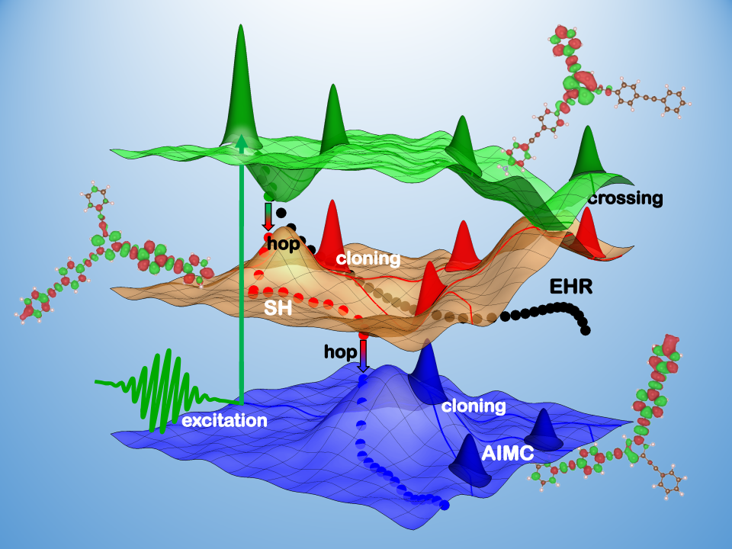

Photoinduced processes of multichromophoric organic conjugated materials frequently involve concerted dynamics of coupled electronic and vibrational degrees of freedom (i.e. vibronic couplings) that can give rise to multiple relaxation pathways, and persisting phase relations or coherences. Fundamental insights into the coherence creation and destruction mechanisms can potentially allow the manipulation of photoexcited non-radiative pathways to achieve desired efficient transfer of energy and charges.

Atomistic Non-Adiabatic Excited-State Molecular Dynamics (NEXMD) using quantum/classical methods, like surface hopping (SH), Ehrenfest, and Multiconfigurational Ehrenfest and Ab Initio Multiple Cloning (AIMC) approaches have proved to be suitable for the analysis of exciton redistributions and vibronic dynamics during electronic relaxation in this class of molecular systems [1,2,3]. Particularly, AIMC results in a controllable approximation to non-adiabatic dynamics that naturally includes electronic decoherence. We analyze this by simulating the energy transfer of a rigid synthetic heterodimer. Our results verify their vibronic nature, that survives multiple conical intersection passages for several hundred femtoseconds at room temperature.

Besides, we explore different strategies to increase the efficiency of deactivation of the excess of electronic energy after photoexcitation of chromophores by using donor-acceptor dyads[4], catenanes nanorings[5] and stacking arrangements[6].

Furthermore, we report calculations of transient absorption pump–probe spectra delivering detailed information on photoexcited dynamics of a large four branched dendrimer with a pyrene core. Our analysis reveals an ultrafast intrabranch energy relaxation that takes place before the final exciton capture by the pyrene trap[7].

**References**

[1] "Non-adiabatic Excited State Molecular Dynamics: theory and applications for modeling photophysics in extended molecular materials" T. Nelson, A. White, J. Bjorgaard, A. Sifain, Y. Zhang, B. Nebgen, S. Fernandez-Alberti, D. Mozyrsky, A. Roitberg, and S. Tretiak, Chem.

Rev., 120, 4, 2215-2287 (2020).

[2] “Ab initio multiple cloning algorithm for quantum nonadiabatic molecular dynamics” D. V. Makhov, W. J. Glover, T. J. Martinez and D. V. Shalashilin, J. Chem. Phys.,

141, 054110 (2014).

[3] “An Ab Initio Multiple Cloning approach for the simulation of photoinduced dynamics in conjugated molecules” V. M. Freixas, S. Fernandez-Alberti, D. V. Makhov, S. Tretiak, and D. Shalashilin, Phys. Chem. Chem. Phys. 20, 17762 - 17772 (2018).

[4] “Back-and-forth Energy Transfer During Electronic Relaxation in a Chlorin-perylene Dyad” Galindo, J. F; Freixas, V. M.; Tretiak, S. and Fernandez-Alberti, S., J. Phys. Chem. Lett. 12, 42, 10394–10401 (2021).

[5] “The Impact of Stacking and Phonon Environment on Energy Transfer in Organic Chromophores: Computational Insights” A. Mukazhanova, H. Negrin-Yuvero, V. M. Freixas, S. Tretiak, S. Fernandez-Alberti, S. Sharifzadeh, J. Mater. Chem. C, 11, 5297 (2023).

[6] “Tuning electronic relaxation of nanorings through their interlocking.” L. Alfonso-Hernandez, V. M. Freixas, T. Gibson, S. Tretiak, S. Fernandez-Alberti, (submitted to J. Comput. Chem.).

[7] “Transient-Absorption Spectroscopy of Dendrimers via Nonadiabatic Excited-State Dynamics Simulations”, R. Perez-Castillo, V. M. Freixas, S. Mukamel, A. Martinez-Mesa, Ll. Uranga-Piña, S. Tretiak, M. F. Gelin, and S. Fernandez-Alberti, Chem. Sci. 15, 13250-13261 (2024)

**Aperiodic fragments embedded in periodic solids: Eliminating the need for supercells and background charges in electronic structure calculations of defects**

Rob Lavroff, Daniel Kats, Lorenzo Maschio, Nikolay Bogdanov, Ali Alavi, Anastassia Alexandrova, and Denis Usvyat

*University of California, Los Angeles, CA, USA; Email:* [*lavroff@g.ucla.edu*](mailto:lavroff@g.ucla.edu)

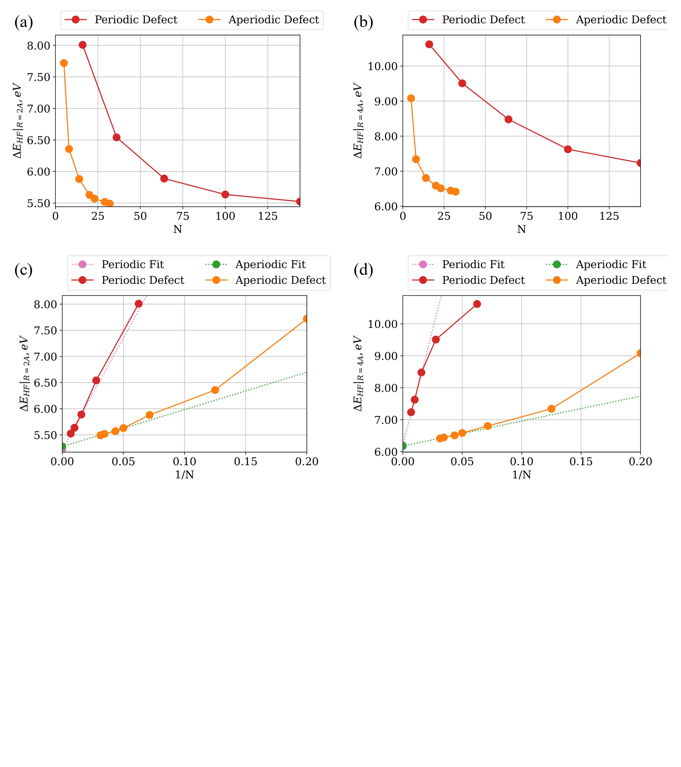

To date, computational methods for modeling defects (vacancies, adsorbates, etc.) rely on periodic supercells in which the defect is far enough from its repeated image such that they can be assumed non-interacting. Defects in real solids, however, can be spaced microns or more apart, whereas affordable supercells for density functional theory calculations are no wider than a few nanometers. The relative proximity and periodic repetition of the defect’s images may lead to spurious, unphysical artifacts, especially if the defect is charged and/or open-shell. Furthermore, to avoid divergence of the periodic electrostatics, a compensating background charge must be introduced if the defect is charged. Even if post-hoc corrections are used, this is a source of unquantifiable error and, in some cases, renders total energies and energy differences useless. In this communication, we introduce a "defectless" embedding formalism such that a pristine, primitive unit cell may be used for the periodic mean field, after which atoms may be moved or charged within an embedded fragment. This fragment can then be treated with a post-Hartree Fock method to capture important electron correlations pertaining to the defect. By eliminating the need for compensating background charges and periodicity of the defect, we circumvent all associated unphysicalities and numerical issues. Furthermore, the primitive cell calculations drastically reduce computational expense compared to supercell approaches. This embedded, aperiodic fragment scheme is size-intensive with respect to energy differences and can be routinely applied even to multireference defects, localized excited states, etc. using a variety of fragment solvers. In examining with this approach bond-breaking in a fluorine-substituted graphane monolayer, a difficult testing ground for condensed-phase electronic structure methods, single- and multireference dissociation curves resulting from aperiodic embedding exclude artifacts which do appear in a periodic embedding approach, even with very large supercells. A mere N=32-atom fragment achieves the thermodynamic limit of the Hartree Fock dissociation energy of this 2-D system while a 144-atom supercell is required in the periodic scheme, a massive speedup given the N^4 scaling of Hartree Fock with system size.

**How to connect**

Alexey Akimov is inviting you to a scheduled Zoom meeting.

Topic: VISTA, Seminar 75

Time: Sep 18, 2024 10:00 AM Eastern Time (US and Canada)

Join Zoom Meeting

<https://buffalo.zoom.us/j/91888357058?pwd=q73S6x5xGBbGUeaPSn7QQDVUR4tDkl.1>

Meeting ID: 918 8835 7058

Passcode: 344276